

Practical No: 2

Date: 15th September 2026

Title: Transistor Sampling

Name: Joe Blogs ???

Course: Bachelor of Engineering in Electronic Engineering

Subject: Digital Communications and Transmission

Lecturer: Ben Graham

Summary: Sampling and reconstruction of a sine wave

OBJECTIVES:
To set up sampling and reconstruction circuits to study the sampling theorem and to plot waveforms for different sampling rates.
After the completion of this experiment, students will have good knowledge of
sampling, effect of sampling rate, method of sampling and reconstruction of signals.

COMPONENTS AND EQUIPMENTS REQUIRED:
BC547 NPN Transistor
CD 4066
Resistors – 8.2K Ω, 1K Ω ,470 Ω and 220 Ω
Capacitor- 1µF
Signal Generators.
Oscilloscope
Bread Board
Wires and probes

THEORY:
As a first step to convert any analogue signals into digital form, samples of the analogue signals are taken at regular intervals. The levels of these samples are then encoded and sent to the receiver. Today this sampling and encoding is typically performed using an Analogue to Digital Convertor (ADC).

At the receiver these samples are recovered and from that the original signal is reconstructed.

A basic sampling and reconstruction circuit is shown in Figure 1. A transistor is used as a crude analogue switch to take samples of the sine wave input. Sampling pulses are applied to the base of the transistor that switches it ON and OFF. The input signal is sent to the output only when the transistor is ON. Thus the output of the transistor is a sampled form of the input signal.

The reconstruction circuit is a low pass filter having a cut off frequency equal to the frequency of the analogue input signal.

PROCEDURE:
- Build the circuit in Figure 1 in CircuitMaker

- To change a signal generator from generating a sine wave to a square wave double click on the signal generator, click on the wave tab, set the period according to the required frequency and set the pulse width to 50% of the period.

- Take note of all the waveforms as shown below.

- Vary the sampling frequency above and below 250 Hz, take note of the relevant waveforms and comment on the effect this has on the reconstructed signal.

- State your understanding of Nyquist sampling rate?
- Estimate the phase change between the original waveform and the reconstructed waveform? Compare this to the theoretical value $\left(\tan^{-1}\frac{X_{C}}{R}\right)$.
- Determine the cut off frequency of the reconstruction circuit $f_{c}=\frac{1}{2πRC}$.

- Build the circuit as shown in figure 1 on the bread board and take note of all the waveforms as shown below. Note: Use the MP750510 waveform generator

You will note that the waveform achieved are not perfect this is due to the fact that the transistor is not an ideal switch, introduces voltage drop, its non linear and it also allows small amount of current to discharge when switch is off.

- A better alternative will CMOS analogue switch such as the CD4066.
Obtain datasheet for the CD4066, replace the BJT on your breadboard with the CD4066 and observe if any improvement.

Remember: Sampling is achieved by effectively using a pulse to switch to obtain switched sample analogue signal. This can be achieved very simply with the CD4066. Build circuit on breadboard and confirm output. Explain operation.

CIRCUIT DIAGRAM:

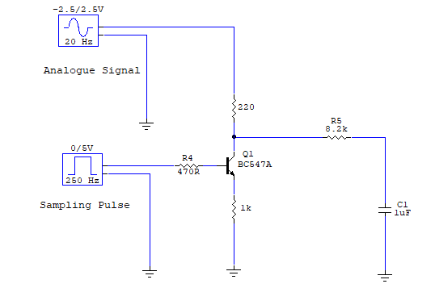
Figure 1: Sampling and reconstruction of a sine wave
WAVEFORMS:

Include the most important waveforms in your report and explain your understand. Do not flood the results section with too many images.

Sampled output
Analogue input signal
Reconstructed signal
Sampling signal

Conclusion
Include a conclusion, explain the need for sampling in digital communications.
Anything of note during this practical.

Digital Communications and Transmission Lab Report Marking Rubric

Standards | > 80% | 65% – 80% | 40 – 65% | < 40% Fail
General Report Layout  (Weight: 10%) | Follows the formal report template structure. Third – person used throughout. | Clear progression through all sections of the draft report. Minor errors, referencing, etc. | Mixes third- person and first. Presentation and structure is inconsistent. Some grammatical or formatting errors. | Hard to follow, fails to follow the report structure. Incomplete, fails to meet basic academic/technical standards.
Procedure / Methodology  (Weight: 30%) | Clear, concise summary of the procedure and methodology. Possible used schematics and images to explain, perfect labelling. In depth knowledge presented | Covers the main steps and setup accurately. Minor details or omissions from diagrams, etc. | Simply copied the lab sheet text without showing personal understanding. | Omits critical steps/sections, unrecognizable, missing entirely.
Data Presentation & Accuracy  (Weight: 30%) | All data presented in a clear and clean manner. Images cropped with image reference used. Correct units used, clear axes, titles used on graphs. Any references included. | Data is accurate and structured. Minor incorrections in units, labelling, axis, etc. | Data is present but disorganized. Units missing, visually poorly presented. Minor calculations error. | Calculations wrong, fabricated data, completely missing data. Unacceptable level of data presented.
Discussion & Error Analysis  (Weight: 30%) | Deep evaluation provided between experimental and data. Clear understanding of sources of error demonstrated. Deep knowledge of the subject. | Correctly compares results to theoretical values. Identifies errors but doesn’t present critical insight.  Knowledge of the subject. | Notes any gaps between theory and results, no discussion or simply blamed as human errors.  Limited knowledge of the subject | No interpretation or engineering context.  No discussion

